COMPUTER SCIENCE PROJECT



SUPERMARKET MANAGEMENT

prepared by:

**GADE MEGHANA // AP21110010701**

**ABBURI SIVA CHANDU // AP21110010702**

**SYAMALA SAI NADH REDDY//**

**AP21110010703**

**C.S.E-K SEC.**

**S.R.M UNIVERSITY AP**

CERTIFICATE

**This to certify that the project report entitled “SUPERMARKET MANAGEMENT” submitted by “GROUP 17” during the academic year 2021 – 2022 is a bonafied piece of work conducted under my supervision and guidance. The data sources have been fully acknowledged.**

**MRS. USHA RANI**

**(PGT COMPUTER SCIENCE)**

**Acknowledgment**

* **I take this opportunity to express my profound sense of gratitude and respect to all those who helped me throughout this venture.**
* **I would like to express my heartfelt thanks to my revered teacher and guide MRS. USHA RANI for her valuable guidance, encouragement and support throughout my studentship under her at class.**
* **Last but not the least; I owe my overwhelming gratitude to my friends and group members who gave me constant support and motivation to continue with this endeavour.**

**GROUP 17**

**C.S.E-K**

**Index**

|  |  |  |
| --- | --- | --- |
| **Sr no** | **Content** | **Page no** |
| **1** | **Introduction** | **5** |
| **2** | **Abstract** | **6** |
| **3** | **Problem definition** | **7** |
| **4** | **Proposed system** | **8** |
| **5** | **Work flow** | **9** |
| **6** | **flow chart and Algorithm** | **10** |
| **7** | **REQUIREMENT ANALYSIS** | **11** |
| **8** | **Source code** | **12-52** |
| **9** | **Output** | **53-54** |
| **10** | **References** | **55** |

**INTRODUCTION**

**The project is on Supermarket management. Supermarket is the place where customers come to purchase their daily using products and pay for that and generate the bill for the customer.**

**In our project we have the customer or the billing manager who can purchase the items available or can make the bill for the customers.**

**This project can also be used for online purchasing as the customer can access it easily.**

PROJECT ABSTRACT

The Project “supermarket” deals with the automation of supermarket This software will help salespersons in managing the various types of Records pertaining to his/her customer. The product will help the user to work Ina highly effective and efficient environment.

The salespersons have been recording the customer information in the past and even in the present through their personal manual efforts. And indeed, it consumes their considerable time and energy that could be utilized in the better productive activities. Apart from that, with increasing customer Strength, the task of managing information of each individual customer is indeed a cumbersome task.

The grocery management application presented here is very simple console application developed using c programming language. It is built without using graphics. It is compiled in code: Blocks using dev c++ compiler. We used files to store data to make this program memory efficient.

PROBLEM DEFINITION

The main purpose of the project is to manage the shopping efficiently for supermarket. Supermarkets are getting crowded these days at the billing area and lot of time is being consumed for billing the products. Also, at the counter the person responsible must go through the whole items which have been taken by the customers, it would be a time-consuming process.

Proposed system

The new system will cater to the need of the salespersons of any supermarket so that they can manage the system efficiently. The project “supermarket” is developed with the objective of making the system reliable, easier, fast, and more informative.

The proposed system helps us to maintain all records of billing and there will be less chance of error in any case. Even it helps to know the year sales and it will be Benefitable.

**Work flow**

Work in the Supermarket will be done in the following way:

1. The product will come in the store.
2. The Administrator will enter the information of the product in database and price for each product.
3. The customer will come and take the basket with him/her and choose the product and take it to the counter.
4. The bill calculating operator will enter the product number then it will show its information and price and the bill will be calculated and total payment will shown.
5. Customer will pay for the products.
6. All the products will be packed and delivered to the customer.

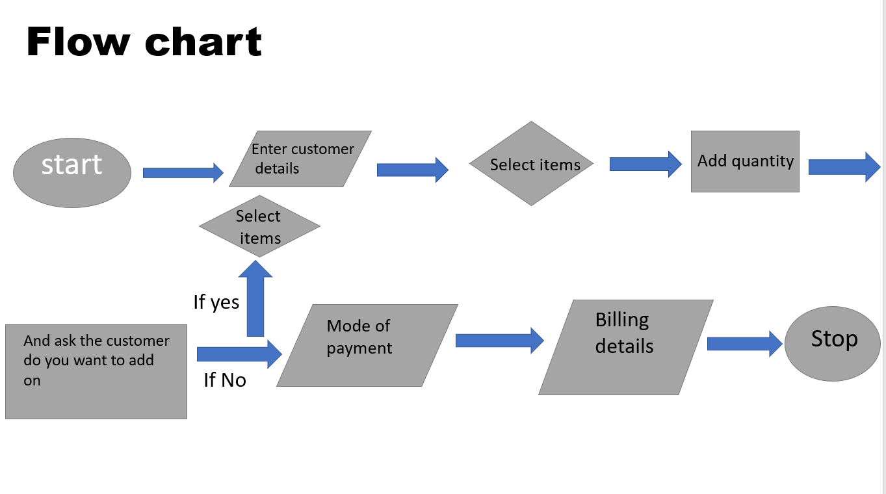

**ALGORITHM**

**Step 1: Start**

**Step 2: Enter customer details**

**Step 3: Select items**

**Step 4: Add quantity**

**Step 5: And ask the customer do you want add on**

**Step 6: If yes (select items)**

**Step 7: If No**

**Step 8: Mode of billing**

**Step 9: Billing Details**

**Step 10: Stop**

**REQUIREMENT ANALYSIS**

**Software Requirement:**

Front end: C language

Back end: Supermarket management.

Operating System: Any Operating system (Windows or Linux)

**Hardware Requirement:**

Processor: 3.06 GHZ operating speed

Hard Disk: 80GB capacity

Ram:256MB

Monitor: CRT 17

Mouse: Optical

Keyboard: Alphanumeric key

SOURCE CODE

#include<stdio.h>

#include<stdlib.h>

float price,t[50],gt[10];

int q[30],x,r[30],f,a;

char name[25];

char adress[50];

long long int num;

int i=50;

int pass;

int j=0;

int main()

{

FILE *gb;

system("COLOR 0e");

heading();

printf("\n Enter your name\n");

scanf("%s",name);

printf("\n Enter your mobile number\n");

scanf("%lld",&num);

printf("\n Enter your adress (village name):\n");

scanf("%s",adress);

items();

gb=fopen("w.txt","a");

if(gb==NULL)

{

printf("\n we couldnot find that file");

}

{

fprintf(gb,"\n\t\t\t###########################################################################");

fprintf(gb,"\n\t\t\t############ ############");

fprintf(gb,"\n\t\t\t############ GROCERRY BILL PROJECT IN C ############");

fprintf(gb,"\n\t\t\t############ ############");

fprintf(gb,"\n\t\t\t###########################################################################");

fprintf(gb,"\n\n\n");

fprintf(gb,"\n\t\t\t----------------------------------------------------------------------------");

fprintf(gb,"\n\t\t\t **-**-**-**-**-**-**-**-**-**-**-**-**-**-**-**-**-**-**\n");

fprintf(gb,"\n\t\t\t =-=-=-=-=-=-=-=-=-=-=-=-=-=-=-=-=-=-=-=-=-=-=");

fprintf(gb,"\n\t\t\t = WELCOME =");

fprintf(gb,"\n\t\t\t = TO =");

fprintf(gb,"\n\t\t\t = MORE =");

fprintf(gb,"\n\t\t\t = SUPER MARKET =");

fprintf(gb,"\n\t\t\t =-=-=-=-=-=-=-=-=-=-=-=-=-=-=-=-=-=-=-=-=-=-=");

fprintf(gb,"\n\t\t\t **-**-**-**-**-**-**-**-**-**-**-**-**-**-**-**-**-**-**\n");

fprintf(gb,"\n\t\t\t----------------------------------------------------------------------------");

fprintf(gb,"\nDate:%s",__DATE__);

fprintf(gb,"\nTIME:%s",__TIME__);

fprintf(gb,"\n Name: %s",name);

fprintf(gb,"\n Mobile number: %lld",num);

fprintf(gb,"\n Adress (village name): %s",adress);

fprintf(gb,"\n The total number of items is-----%d",q[26]);

fprintf(gb,"\n The sub total is-------------------------%2f",t[26]);

fprintf(gb,"\n the G.S.T is------------------------------%2f",gt[1]);

fprintf(gb,"\n The C.G.S.T is----------------------------%2f",gt[2]);

fprintf(gb,"\n The S.G.S.T is----------------------------%2f",gt[3]);

fprintf(gb,"\n The Total including of all Taxes is.----..%2f",gt[5]);

fprintf(gb,"\n You have saved on this purchase-----------%2f",gt[4]);

fprintf(gb,"\n *********Thank You For Visiting visit again***************");

fprintf(gb,"\n If You Have Any Quries call 1800-599-555.\n");

for(i=0;i<50;i++)

{

fprintf(gb,"__");

}

fclose(gb);

}

}

int new();

int new()

{

printf("\n 1-----> new order 2----exit");

scanf("%d",&r[26]);

if(r[26]==1)

{

system("cls");

main();

}

else

{

system("cls");

exit(0);

}

}

int debitcard();

int debitcard()

{

printf("\n You have paid through debit card/creditcard");

t[26]=t[1]+t[2]+t[3]+t[4]+t[5]+t[6]+t[7]+t[8]+t[9]+t[10]+t[11]+t[12]+t[13]+t[14]+t[15]+t[16]+t[17]+t[18]+t[19]+t[20]+t[21]+t[22]+t[23]+t[24]+t[25];

gt[1]=t[26]*0.18;

gt[2]=t[26]*0.09;

gt[3]=t[26]*0.09;

t[27]=gt[1]+t[26];

gt[4]=t[27]*0.015;

gt[5]=t[27]-gt[4];

q[26]=q[1]+q[2]+q[3]+q[4]+q[5]+q[6]+q[7]+q[8]+q[9]+q[10]+q[11]+q[12]+q[13]+q[14]+q[14]+q[15]+q[16]+q[17]+q[18]+q[19]+q[20]+q[21]+q[22]+q[23]+q[24]+q[25];

printf("\n The total number of items is----%d",q[26]);

printf("\n The sub total is -------------%2f",t[26]);

printf("\n the G.S.T is-------------------%2f",gt[1]);

printf("\n The C.G.S.T is-----------------%2f",gt[2]);

printf("\n The S.G.S.T is-----------------%2f",gt[3]);

printf("\n The total including of all taxes is...%f",gt[5]);

printf("\n You have saved %f on this purchase",gt[4]);

printf("\n *********Thank You For Visiting visit again***************");

printf("\n If You Have Any Quries call 1800-599-555.");

printf("\n\n");

printf("\n Do you want to check previous bill (1-yes 2-no)");

scanf("%d",&r[27]);

if(r[27]==1)

{

printf("\n Enter the password to view previous bill:\n");

for(j=0;j<6;j++)

{

scanf("%d",&pass);

{

if(pass==123456)

{

printf("\n Access granted!\n");

previous();

}

else

{

printf("\nIncorrect password, please try again.");

printf("\nYou have %d trys left ",5-j-1);

printf("\n\nEnter password >> ");

}

}

}

}

else

{

new();

}

}

int cashpayment();

int cashpayment()

{

printf("\n You have paid through cash");

t[26]=t[1]+t[2]+t[3]+t[4]+t[5]+t[6]+t[7]+t[8]+t[9]+t[10]+t[11]+t[12]+t[13]+t[14]+t[15]+t[16]+t[17]+t[18]+t[19]+t[20]+t[21]+t[22]+t[23]+t[24]+t[25];

gt[1]=t[26]*0.15;

gt[2]=t[26]*0.08;

gt[3]=t[26]*0.07;

t[27]=gt[1]+t[26];

gt[4]=t[27]*0.015;

gt[5]=t[27]-gt[4];

q[26]=q[1]+q[2]+q[3]+q[4]+q[5]+q[6]+q[7]+q[8]+q[9]+q[10]+q[11]+q[12]+q[13]+q[14]+q[14]+q[15]+q[16]+q[17]+q[18]+q[19]+q[20]+q[21]+q[22]+q[23]+q[24]+q[25];

printf("\n The total number of items is----%d",q[26]);

printf("\n The sub total is -------------%2f",t[26]);

printf("\n the G.S.T is-------------------%2f",gt[1]);

printf("\n The C.G.S.T is-----------------%2f",gt[2]);

printf("\n The S.G.S.T is-----------------%2f",gt[3]);

printf("\n The total including of all taxes is...%f",gt[5]);

printf("\n You have saved %f on this purchase",gt[4]);

printf("\n *********Thank You For Visiting visit again***************");

printf("\n If You Have Any Quries call 1800-599-555.");

printf("\n\n");

printf("\n Do you want to check previous bill (1-yes 2-no)");

scanf("%d",&r[27]);

if(r[27]==1)

{

printf("\n Enter the password to view previous bill:\n");

for(j=0;j<6;j++)

{

scanf("%d",&pass);

{

if(pass==123456)

{

printf("\n Access granted!\n");

previous();

}

else

{

printf("\nIncorrect password, please try again.");

printf("\nYou have %d trys left ",5-j-1);

printf("\n\nEnter password >> ");

}

}

}

}

else

{

new();

}

}

int heading();

int heading()

{

printf("\t\t\t###########################################################################");

printf("\n\t\t\t############ ############");

printf("\n\t\t\t############ GROCERRY BILL PROJECT IN C ############");

printf("\n\t\t\t############ ############");

printf("\n\t\t\t###########################################################################");

printf("\n\n\n\n");

printf("\n\t\t\t----------------------------------------------------------------------------");

printf("\n\t\t\t **-**-**-**-**-**-**-**-**-**-**-**-**-**-**-**-**-**-**\n");

printf("\n\t\t\t =-=-=-=-=-=-=-=-=-=-=-=-=-=-=-=-=-=-=-=-=-=-=");

printf("\n\t\t\t = WELCOME =");

printf("\n\t\t\t = TO =");

printf("\n\t\t\t = MORE =");

printf("\n\t\t\t = SUPER MARKET =");

printf("\n\t\t\t =-=-=-=-=-=-=-=-=-=-=-=-=-=-=-=-=-=-=-=-=-=-=");

printf("\n\t\t\t **-**-**-**-**-**-**-**-**-**-**-**-**-**-**-**-**-**-**\n");

printf("\n\t\t\t----------------------------------------------------------------------------");

}

int previous();

int previous()

{

FILE *pre;

char z;

pre=fopen("w.txt","r");

while((z=fgetc(pre))!=-1)//-1 is the value of EOF//

{

printf("%c",z);

}

if(getch())

system("cls");

printf(" Enter 1 to go main menu\n");

main();

}

int total();

int total()

{

printf("\n Mode of payment \n1---->credit card/Debit card. \t2---->cash payment.");

scanf("%d",&f);

if(f==1)

{

debitcard();

}

else if(f==2)

{

cashpayment();

}

else

{

system("COLOR 4");

printf("\n Invalid error");

}

}

int items();

int items()

{

system("cls");

int x;

printf("Item Code----Description-----------------------------Size--------------------------------------------Price\n");

printf("[1]---------Thums-Up Soft Drink----------------------2.25litres--------------------------------------83.50\n");

printf("[2]---------Dark Chocolate Peanut Butter-------------1kg--------------------------------------------325.00\n");

printf("[3]---------Presto! 2 Ply Kitchen Tissue-6 Rolls-----1box-------------------------------------------380.00\n");

printf("[4]---------Pillsbury Signature Chocolate Cake Mix---1kg--------------------------------------------180.00\n");

printf("[5]---------Kissan Squeezo Fresh Tomato Ketchup------900ml------------------------------------------140.00\n");

printf("[6]---------Cadbury Dairy Milk Chocolate Bars--------126g--------------------------------------------65.00\n");

printf("[7]---------Life Oats Chips--------------------------1kg---------------------------------------------70.00\n");

printf("[8]---------Cadbury OREO Cracker Biscuit-------------126g-------------------------------------------100.00\n");

printf("[9]---------Nescafe Sunrise Instant Coffee-----------200g-------------------------------------------130.00\n");

printf("[10]--------3 Roses Tea Box--------------------------250g-------------------------------------------150.00\n");

printf("[11]--------Freedom Refined Sunflower Oil Can--------5L---------------------------------------------790.00\n");

printf("[12]--------Parachute Coconut Hair Oil---------------400ml------------------------------------------140.00\n");

printf("[13]--------AASHIRVAAD Atta with Multigrains---------10kg-------------------------------------------550.00\n");

printf("[14]--------Vedaka Sugar-----------------------------5kg--------------------------------------------240.00\n");

printf("[15]--------Tata Salt--------------------------------1kg---------------------------------------------18.00\n");

printf("[16]--------Catch Black Pepper-----------------------100g--------------------------------------------65.00\n");

printf("[17]--------Santoor Sandalwood Soap(pack of 8)-------125g-------------------------------------------240.00\n");

printf("[18]--------Surf Excel Detergent Bar-----------------800g-------------------------------------------200.00\n");

printf("[19]--------Tata Sampann Unpolished Toor Dal---------1kg--------------------------------------------150.00\n");

printf("[20]--------Tata Sampann Unpolished Urad Dal---------1kg---------------------------------------------90.00\n");

printf("[21]--------Roasted Nuts with Wayanad Pepper---------200g--------------------------------------------70.00\n");

printf("[22]--------Tata Salt baking Soda--------------------100g--------------------------------------------13.00\n");

printf("[23]--------Organic Brown Chana----------------------500g--------------------------------------------25.00\n");

printf("[24]--------Sona Masoori Rice------------------------5 kg-------------------------------------------180.00\n");

printf("[25]--------nuts-------------------------------------200g-------------------------------------------180.00\n");

printf("\n please select the option from the list:\n");

scanf("%d",&x);

switch(x)

{

case 1:

{

system("cls");

printf("You have selected Thums-Up Soft Drink (2.25L) \n");

printf("\n Enter the quantity:\n");

scanf("%d",&q[1]);

price=83.50;

t[1]=price*q[1];

printf("\n Do you want add on(1---->yes 2---->no)");

scanf("%d",&r[1]);

if(r[1]==1)

{

items();

}

if(r[1]==2)

{

total();

}

{

break;

}

if(r[1]>>2)

{

printf("\n Invalid number");

}

}

case 2:

{

system("cls");

printf("You have selected Dark Chocolate Peanut Butter (1kg) \n");

printf("\n Enter the quantity:\n");

scanf("%d",&q[2]);

price=325.00;

t[2]=price*q[2];

printf("\n Do you want add on(1---->yes 2---->no)");

scanf("%d",&r[2]);

if(r[2]==1)

{

items();

}

if(r[2]==2)

{

total();

}

{

break;

}

if(r[2]>>2)

{

printf("\n Invalid number");

}

}

case 3:

{

system("cls");

printf("You have selected Presto! 2 Ply Kitchen Tissue-6 Rolls (1box) \n");

printf("\n Enter the quantity:\n");

scanf("%d",&q[3]);

price=380.00;

t[3]=price*q[3];

printf("\n Do you want add on(1---->yes 2---->no)");

scanf("%d",&r[3]);

if(r[3]==1)

{

items();

}

if(r[3]==2)

{

total();

}

{

break;

}

if(r[3]>>2)

{

printf("\n Invalid number");

}

}

case 4:

{

system("cls");

printf("You have selected Pillsbury Signature Chocolate Cake Mix (1kg) \n");

printf("\n Enter the quantity:\n");

scanf("%d",&q[4]);

price=180.00;

t[4]=price*q[4];

printf("\n Do you want add on(1---->yes 2---->no)");

scanf("%d",&r[4]);

if(r[4]==1)

{

items();

}

if(r[4]==2)

{

total();

}

{

break;

}

if(r[4]>>2)

{

printf("\n Invalid number");

}

}

case 5:

{

system("cls");

printf("You have selected Kissan Squeezo Fresh Tomato Ketchup (900ml) \n");

printf("\n Enter the quantity:\n");

scanf("%d",&q[5]);

price=140.00;

t[5]=price*q[5];

printf("\n Do you want add on(1---->yes 2---->no)");

scanf("%d",&r[5]);

if(r[5]==1)

{

items();

}

if(r[5]==2)

{

total();

}

{

break;

}

if(r[5]>>2)

{

printf("\n Invalid number");

}

}

case 6:

{

system("cls");

printf("You have selected Cadbury Dairy Milk Chocolate Bars (126g) \n");

printf("\n Enter the quantity:\n");

scanf("%d",&q[6]);

price=65.00;

t[6]=price*q[6];

printf("\n Do you want add on(1---->yes 2---->no)");

scanf("%d",&r[6]);

if(r[6]==1)

{

items();

}

if(r[6]==2)

{

total();

}

{

break;

}

if(r[6]>>2)

{

printf("\n Invalid number");

}

}

case 7:

{

system("cls");

printf("You have selected Life Oats Chips (1kg) \n");

printf("\n Enter the quantity:\n");

scanf("%d",&q[7]);

price=210.00;

t[7]=price*q[7];

printf("\n Do you want add on(1---->yes 2---->no)");

scanf("%d",&r[7]);

if(r[7]==1)

{

items();

}

if(r[7]==2)

{

total();

}

{

break;

}

if(r[7]>>2)

{

printf("\n Invalid number");

}

}

case 8:

{

system("cls");

printf("You have selected Cadbury OREO Cracker Biscuit (126g) \n");

printf("\n Enter the quantity:\n");

scanf("%d",&q[8]);

price=100.00;

t[8]=price*q[8];

printf("\n Do you want add on(1---->yes 2---->no)");

scanf("%d",&r[8]);

if(r[8]==1)

{

items();

}

if(r[8]==2)

{

total();

}

{

break;

}

if(r[8]>>2)

{

printf("\n Invalid number");

}

}

case 9:

{

printf("You have selected Nescafe Sunrise Instant Coffee (200g) \n");

printf("\n Enter the quantity:\n");

scanf("%d",&q[9]);

price=130.00;

t[9]=price*q[9];

printf("\n Do you want add on(1---->yes 2---->no)");

scanf("%d",&r[9]);

if(r[9]==1)

{

items();

}

if(r[9]==2)

{

total();

}

{

break;

}

if(r[9]>>2)

{

printf("\n Invalid number");

}

}

case 10:

{

system("cls");

printf("You have selected 3 Roses Tea Box (250g) \n");

printf("\n Enter the quantity:\n");

scanf("%d",&q[10]);

price=150.00;

t[10]=price*q[10];

printf("\n Do you want add on(1---->yes 2---->no)");

scanf("%d",&r[10]);

if(r[10]==1)

{

items();

}

if(r[10]==2)

{

total();

}

{

break;

}

if(r[10]>>2)

{

printf("\n Invalid number");

}

}

case 11:

{

system("cls");

printf("You have selected Freedom Refined Sunflower Oil Can (5L) \n");

printf("\n Enter the quantity:\n");

scanf("%d",&q[11]);

price=790.00;

t[11]=price*q[11];

printf("\n Do you want add on(1---->yes 2---->no)");

scanf("%d",&r[11]);

if(r[11]==1)

{

items();

}

if(r[11]==2)

{

total();

}

{

break;

}

if(r[11]>>2)

{

printf("\n Invalid number");

}

}

case 12:

{

system("cls");

printf("You have selected Parachute Coconut Hair Oil (400ml) \n");

printf("\n Enter the quantity:\n");

scanf("%d",&q[12]);

price=140.00;

t[12]=price*q[12];

printf("\n Do you want add on(1---->yes 2---->no)");

scanf("%d",&r[12]);

if(r[12]==1)

{

items();

}

if(r[12]==2)

{

total();

}

{

break;

}

if(r[12]>>2)

{

printf("\n Invalid number");

}

}

case 13:

{

system("cls");

printf("You have selected AASHIRVAAD Atta with Multigrains (10kg) \n");

printf("\n Enter the quantity:\n");

scanf("%d",&q[13]);

price=550.00;

t[13]=price*q[13];

printf("\n Do you want add on(1---->yes 2---->no)");

scanf("%d",&r[13]);

if(r[13]==1)

{

items();

}

if(r[13]==2)

{

total();

}

{

break;

}

if(r[13]>>2)

{

printf("\n Invalid number");

}

}

case 14:

{

system("cls");

printf("You have selected Vedaka Sugar (240) \n");

printf("\n Enter the quantity:\n");

scanf("%d",&q[14]);

price=240.00;

t[14]=price*q[14];

printf("\n Do you want add on(1---->yes 2---->no)");

scanf("%d",&r[14]);

if(r[14]==1)

{

items();

}

if(r[14]==2)

{

total();

}

{

break;

}

if(r[14]>>2)

{

printf("\n Invalid number");

}

}

case 15:

{

system("cls");

printf("You have selected Tata Salt\n");

printf("\n Enter the quantity:\n");

scanf("%d",&q[15]);

price=18.00;

t[15]=price*q[15];

printf("\n Do you want add on(1---->yes 2---->no)");

scanf("%d",&r[15]);

if(r[15]==1)

{

items();

}

if(r[15]==2)

{

total();

}

{

break;

}

if(r[15]>>2)

{

printf("\n Invalid number");

}

}

case 16:

{

system("cls");

printf("You have selected Catch Black Pepper (100g) \n");

printf("\n Enter the quantity:\n");

scanf("%d",&q[16]);

price=65.00;

t[16]=price*q[16];

printf("\n Do you want add on(1---->yes 2---->no)");

scanf("%d",&r[16]);

if(r[16]==1)

{

items();

}

if(r[16]==2)

{

total();

}

{

break;

}

if(r[16]>>2)

{

printf("\n Invalid number");

}

}

case 17:

{

system("cls");

printf("You have selected Santoor Sandalwood Soap (pack of 8) \n");

printf("\n Enter the quantity:\n");

scanf("%d",&q[17]);

price=240.00;

t[17]=price*q[17];

printf("\n Do you want add on(1---->yes 2---->no)");

scanf("%d",&r[17]);

if(r[17]==1)

{

items();

}

if(r[17]==2)

{

total();

}

{

break;

}

if(r[17]>>2)

{

printf("\n Invalid number");

}

}

case 18:

{

system("cls");

printf("You have selected Surf Excel Detergent Bar (800g) \n");

printf("\n Enter the quantity:\n");

scanf("%d",&q[18]);

price=200.00;

t[18]=price*q[18];

printf("\n Do you want add on(1---->yes 2---->no)");

scanf("%d",&r[18]);

if(r[18]==1)

{

items();

}

if(r[18]==2)

{

total();

}

{

break;

}

if(r[18]>>2)

{

printf("\n Invalid number");

}

}

case 19:

{

system("cls");

printf("You have selected Tata Sampann Unpolished Toor Dal (1kg) \n");

printf("\n Enter the quantity:\n");

scanf("%d",&q[19]);

price=150.00;

t[19]=price*q[19];

printf("\n Do you want add on(1---->yes 2---->no)");

scanf("%d",&r[19]);

if(r[19]==1)

{

items();

}

if(r[19]==2)

{

total();

}

{

break;

}

if(r[19]>>2)

{

printf("\n Invalid number");

}

}

case 20:

{

system("cls");

printf("You have selected Tata Sampann Unpolished Urad Dal (1kg) \n");

printf("\n Enter the quantity:\n");

scanf("%d",&q[20]);

price=90.00;

t[20]=price*q[20];

printf("\n Do you want add on(1---->yes 2---->no)");

scanf("%d",&r[20]);

if(r[20]==1)

{

items();

}

if(r[20]==2)

{

total();

}

{

break;

}

if(r[20]>>2)

{

printf("\n Invalid number");

}

}

case 21:

{

system("cls");

printf("You have selected Roasted Nuts with Wayanad Pepper (200g) \n");

printf("\n Enter the quantity:\n");

scanf("%d",&q[21]);

price=70.00;

t[21]=price*q[21];

printf("\n Do you want add on(1---->yes 2---->no)");

scanf("%d",&r[21]);

if(r[21]==1)

{

items();

}

if(r[21]==2)

{

total();

}

{

break;

}

if(r[21]>>2)

{

printf("\n Invalid number");

}

}

case 22:

{

system("cls");

printf("You have selected Tata Salt baking Soda (100g) \n");

printf("\n Enter the quantity:\n");

scanf("%d",&q[22]);

price=13.00;

t[22]=price*q[22];

printf("\n Do you want add on(1---->yes 2---->no)");

scanf("%d",&r[22]);

if(r[22]==1)

{

items();

}

if(r[22]==2)

{

total();

}

{

break;

}

if(r[22]>>2)

{

printf("\n Invalid number");

}

}

case 23:

{

system("cls");

printf("You have selected Organic Brown Chana (500g) \n");

printf("\n Enter the quantity:\n");

scanf("%d",&q[23]);

price=25.00;

t[23]=price*q[23];

printf("\n Do you want add on(1---->yes 2---->no)");

scanf("%d",&r[23]);

if(r[23]==1)

{

items();

}

if(r[23]==2)

{

total();

}

{

break;

}

if(r[23]>>2)

{

printf("\n Invalid number");

}

}

case 24:

{

system("cls");

printf("You have selected Sona Masoori Rice (5kg) \n");

printf("\n Enter the quantity:\n");

scanf("%d",&q[24]);

price=180.00;

t[24]=price*q[24];

printf("\n Do you want add on(1---->yes 2---->no)");

scanf("%d",&r[24]);

if(r[24]==1)

{

items();

}

if(r[24]==2)

{

total();

}

{

break;

}

if(r[24]>>2)

{

printf("\n Invalid number");

}

}

case 25:

{

system("cls");

printf("You have selected nuts\n");

printf("\n Enter the quantity:\n");

scanf("%d",&q[25]);

price=180.00;

t[25]=price*q[25];

printf("\n Do you want add on(1---->yes 2---->no)");

scanf("%d",&r[25]);

if(r[25]==1)

{

items();

}

if(r[25]==2)

{

total();

}

{

break;

}

if(r[25]>>2)

{

printf("\n Invalid number");

}

}

default:

{

printf("\n Enter the numbers from 1-25");

}

}

}

**OUTPUT**

CUSTOMERDETAILS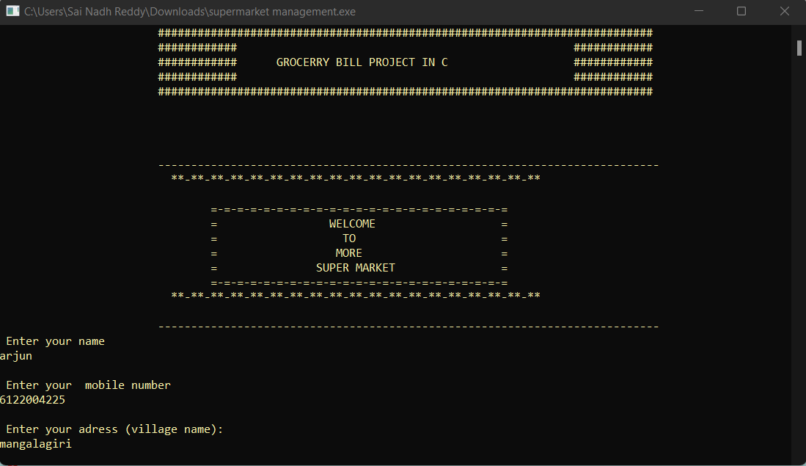ITEMS LIST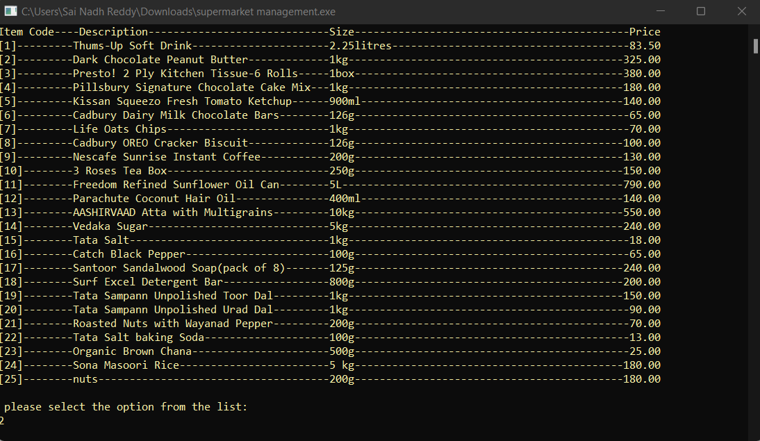

BILL

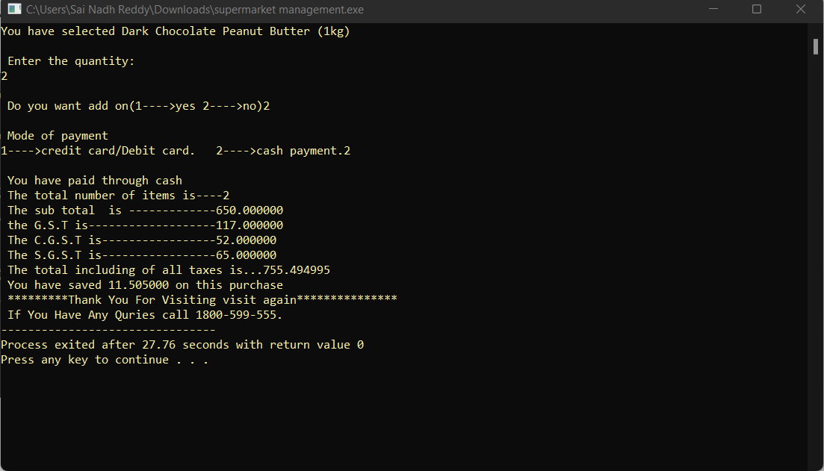

THE CUSTOMER DETAILS WILL BE STORED AS TXT FILE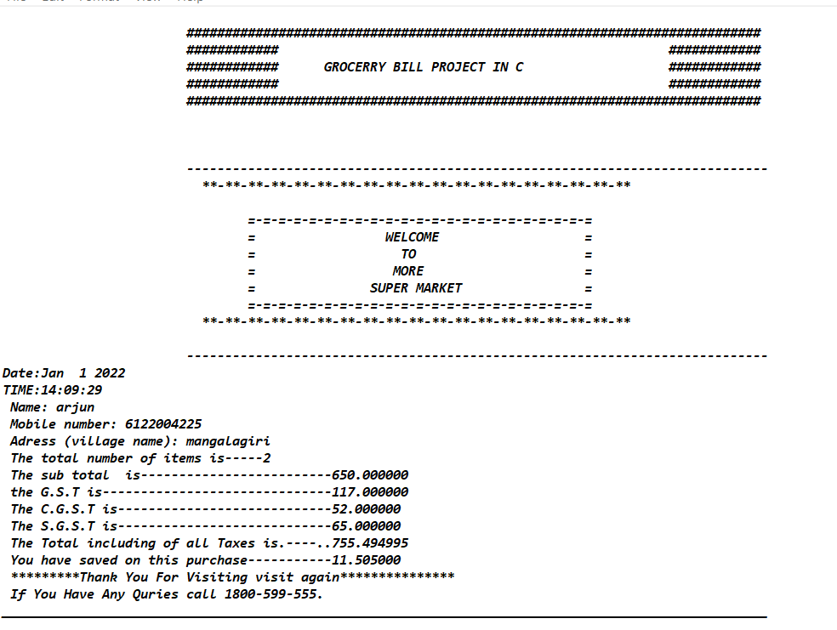

Future prospects

Now this is able to generate super market management. In future we may develop it. So that it can also store/record the generated super market management and we can see the generated super market management of particular person.

References

We used the PPT’S from our c programming course and we took help from seniors for writing code of the project. We also referred websites like [www.w3schools.com](http://www.w3schools.com) and www.tutorialspoint.com.